**Anthony Simon**

**SD7 09 May 2020**

**Project 16 CSS &**

**Responsive Design**

CSS & Responsive Design

We can use responsive design to resize or reposition elements on a web application to improve the user experience by matching the page to the user's device.

Review this article [https://blog.froont.com/9-basic-principles-of-responsive-web-design/ (Links to an external site.)](https://blog.froont.com/9-basic-principles-of-responsive-web-design/) and from each of the 9 highlighted principles, understanding these concepts, select your approach to each of the elements on your pages and indicate your approach to not less than four (4) of the following ideas.

* *responsive vs adaptive design*
* *using static or relative sizes?*
* *flow or static positioning for headers/footers/background images...*
* *using breakpoints*
* *max and min values?*
* *nesting objects (use partial views?)*
* _design for mobile- or desktop- first
* *fonts*
* *vector vs bitmaps*

**Submit (4 tasks!)** Document (MS-Word or PDF) with **screenshots AND descriptive text** illustrating

1. Desktop View
2. Mobile View (use the responsive design tool in Google Chrome browser)
3. *Rotated* mobile view _for at least one or two pages (not a login screen) fpr your app. The text should indicate which of the approaches you used to enable responsive design.

**Additionally!**

1. screenshot your next (Sprint 3?) week's sprint planning board

**For my design I chose to go with a ‘Responsive’ design vs an adaptive using percentages. My objects move with ‘flow’ versus static using ‘relative units’ again using percentages instead of static. I do not currently use breakpoint though I can see the advantage of them. And I am using Min and Max values just to ensure the items are not too big or too small. I do not have anything nested and have no idea about mobile or desktop first. I am using system fonts to ensure readability and compatibility and vector my images for smooth graphics no matter the size.**

1. Desktop View (Voter Site) - Landscape

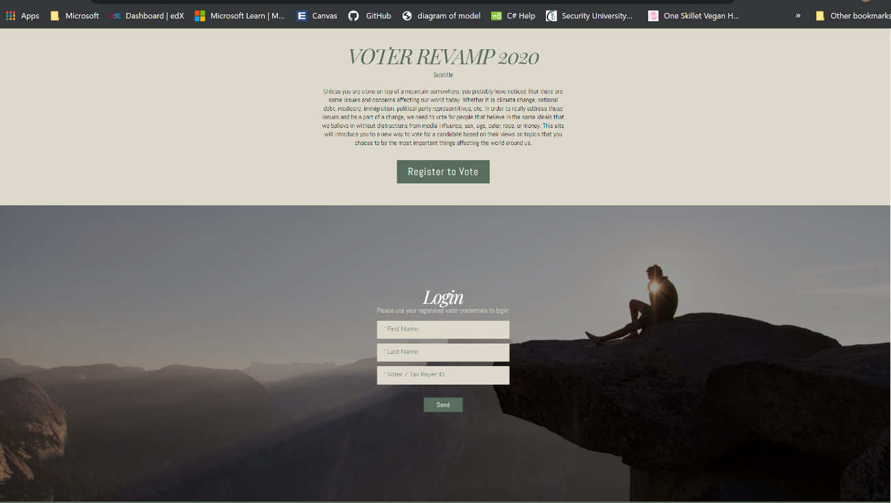

Desktop View (Issues Site) - Landscape

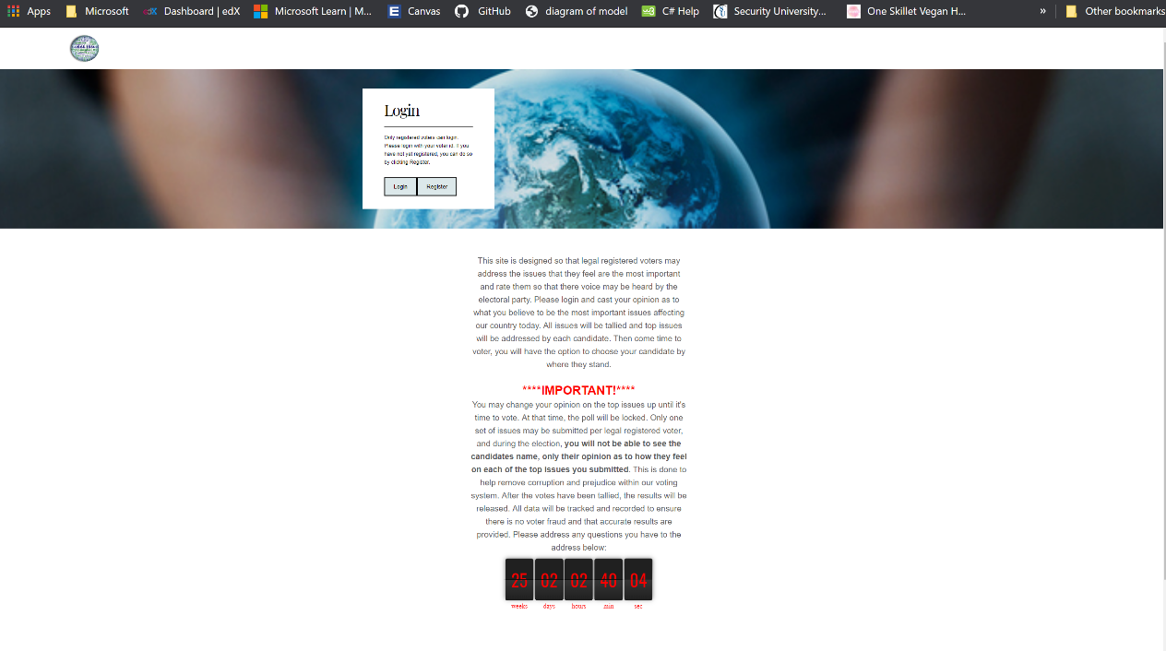

Portrait View (Voter Site) Portrait View (Issues Site)

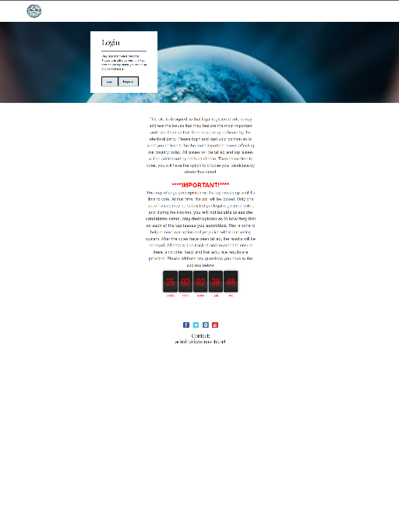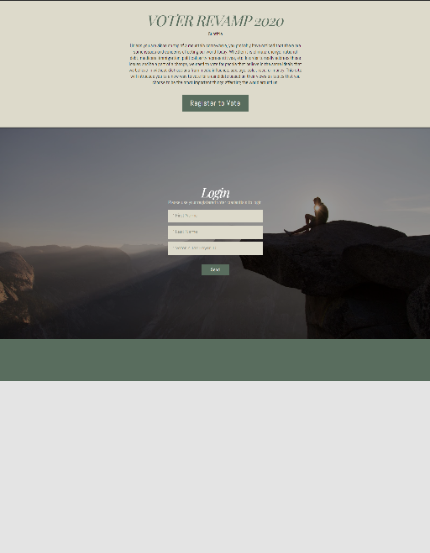

1. Mobile View (use the responsive design tool in Google Chrome browser)

Mobile Landscape (Voter Site)

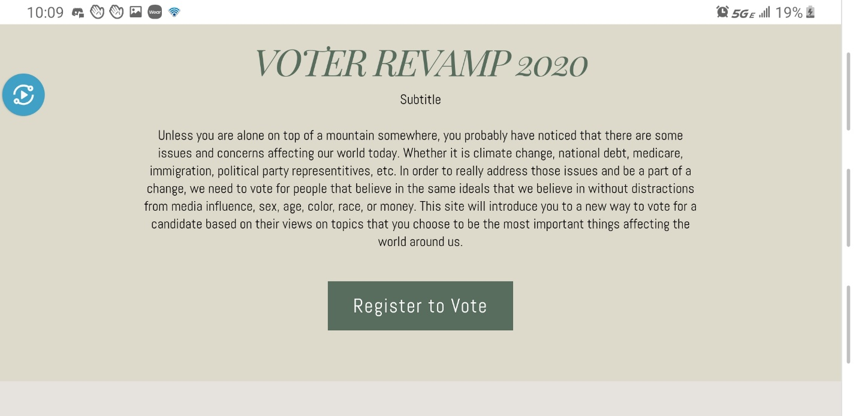

Mobile Landscape (Issues Site - Top)

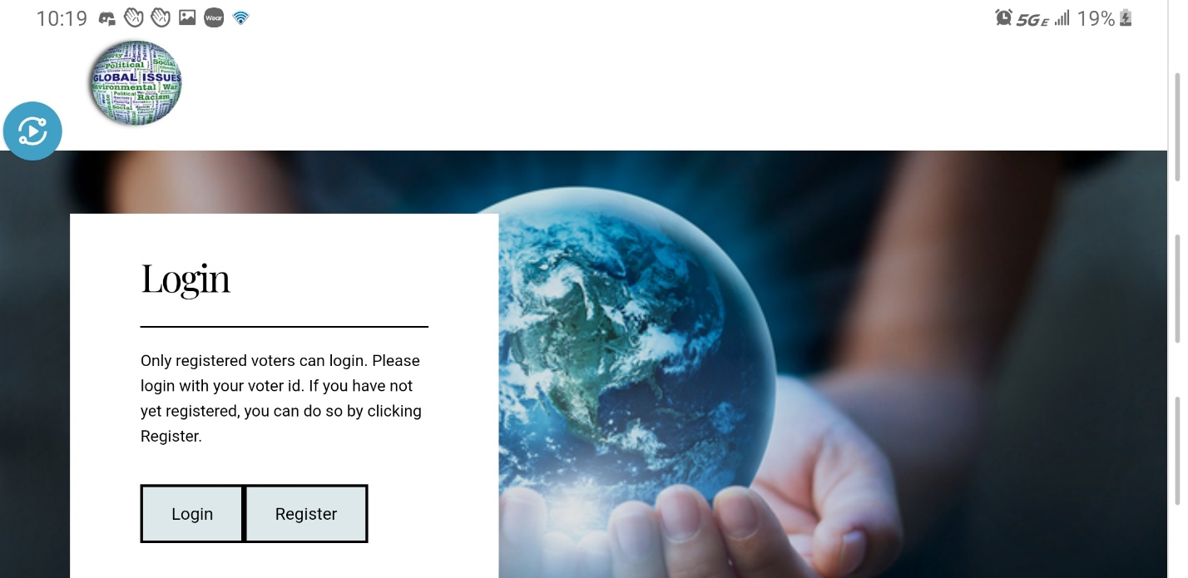

Mobile Landscape (Issues Site – Bottom)

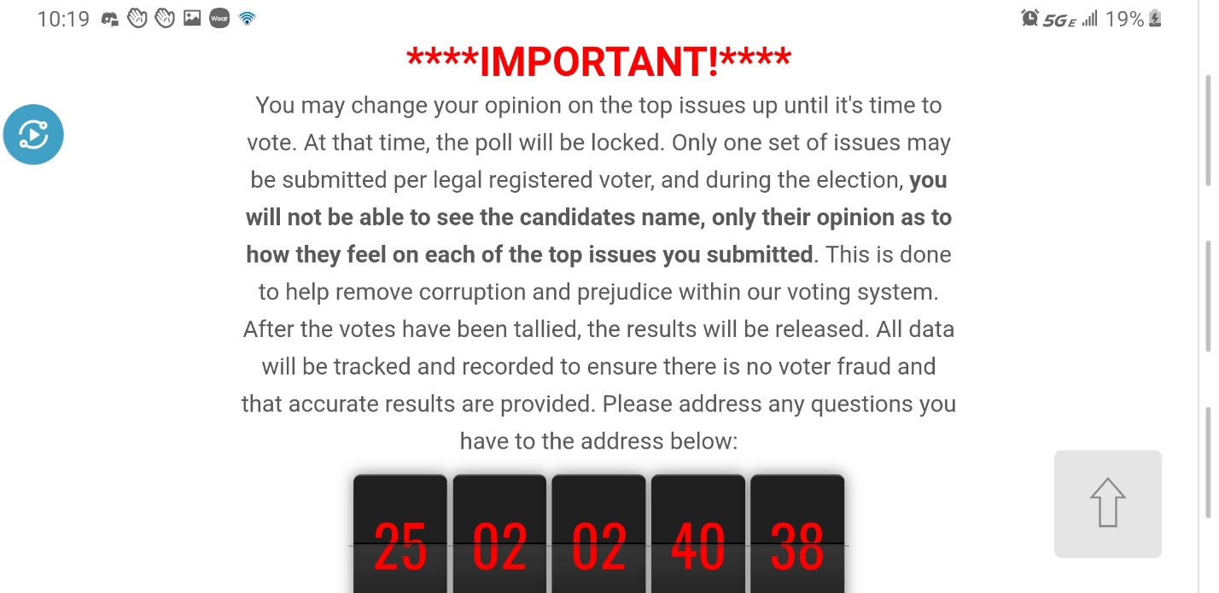

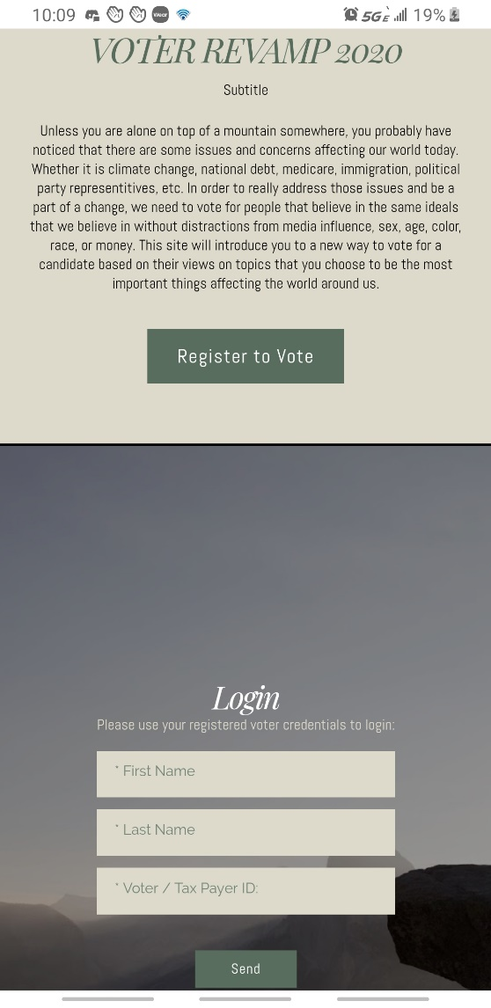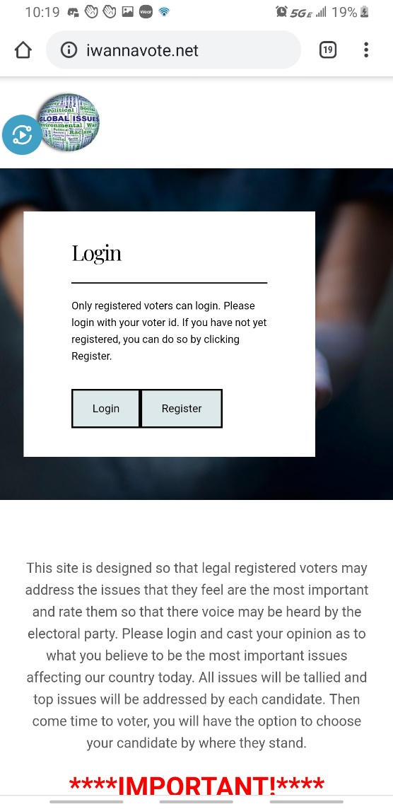Mobile Portrait View (Voter Site)  Mobile Portrait View (Issues Site)

Burn Down Chart

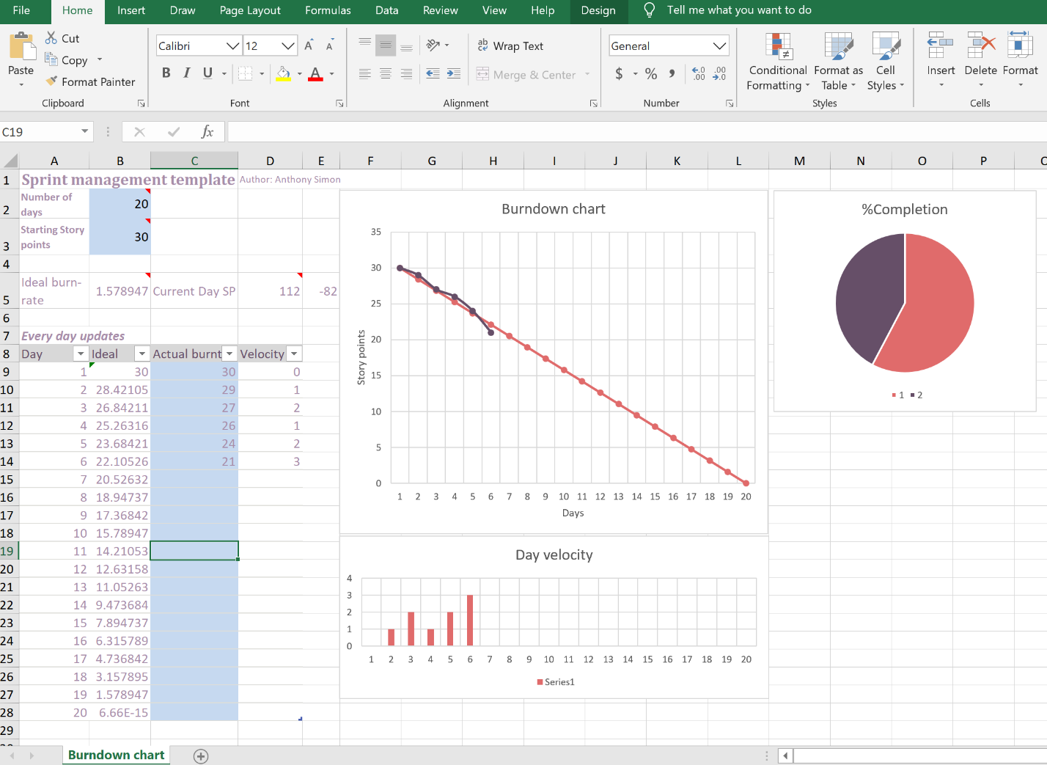

Sprint 3 Planning Board

